Name:
Group 8
Registration Number: SM/SMS/09/00
Title: DETERMINATION OF SOLID BODIES
Experiment 3
Date: 7th October 2009

Date: 7th October, 2009
Title: DEFORMATION OF SOLID BODIES
Aim: To measure the deformation caused by the weight of “mass pieces” on two helical springs.
Apparatus: Support base, support rod (600mm), double clamp, Weight holder (10g), slotted weight (10g), slotted weight (50g), Helical spring (3N/m), helical spring (20N/m), holding pin, glass tube holder and measuring tape (2m).
Diagram:

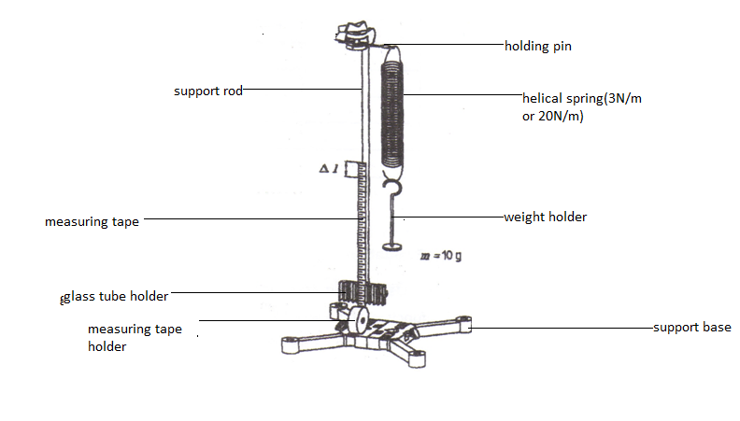
Theory: Hooke’s law states that provide the elastic limit is not exceeded, the extension in the elastic material is proportional to the load or the force applied, F. If an applied force varies linearly with position, the force can be defined as where is called the force constant. One such physical system where this force exists is with common helical spring acting on a body. If the spring is stretched or compressed a small distance from its equilibrium position, the spring will exert a force on the body given by Hooke's Law, namely
Procedure: A stand with a support base, support rod and double clamp was set up. The holding pin was fixed in the double clamp and the 3N/m helical spring was hung on it. A glass tube holder and a measuring tape were clamped on the base. The length of the measuring tape was adjusted such that its zero mark was exactly at the same level as the lower end of the helical spring. A weight holder (m=10g) was hanged on the hooked end of the helical spring and the extension Δl was recorded. The mass was increased by 10g increments to a total of 50g and the corresponding extensions Δl was read. All the values of the mass m and the extension Δl were recorded as in a table.
A 20 N/m helical spring was hanged on the holding pin and the measuring tape was adjusted until its zero mark was even with the lower end of the spring. The weight holder with a 10g mass piece (sum = 20) was hanged on the spring’s hook and the extension Δl was recorded. The mass was increased in 20g increments up to a total of 200g and the corresponding extensions in length were determined. These values were also recorded in a table.

Observation:
Helical spring 3N/m
Mass m/g | Weight(force) F_{g}/N | Deflection ∆l/cm
10.0 | 0.1 | 3.2
20.0 | 0.2 | 6.2
30.0 | 0.3 | 9.2
40.0 | 0.4 | 12.2
50.0 | 0.5 | 15.2

Helical spring 20N/m
Mass m/g | Weight(force) F_{g}/N | Deflection ∆l/cm
20.0 | 0.2 | 1.2
40.0 | 0.4 | 2.2
60.0 | 0.6 | 3.2
80.0 | 0.8 | 4.2
100 | 1.0 | 5.2
120 | 1.2 | 6.2
140 | 1.4 | 7.2
160 | 1.6 | 8.2
180 | 1.8 | 9.2
200 | 2.0 | 10.2

Both graphs have positive gradient.
The 3N/m helical spring displaces more than the 20N/m helical spring.
None of the springs is deformed by the mass pieces since they both did not attain their elastic limit.
No, the values of the two springs lie on two different straight lines.
Yes, the extension ∆l is proportional to the weight(force) F and thus the mass m.
K₁ =∆l₁/Fg₁; k₁=
K₂=∆l₂/Fg_{2;} k₂=

DIscussion: From the data obtained from using the 3N/m helical spring, when the mass was 10.0g the deflection was 3.0cm and weight obtained was 0.1F_{g}/N and as the mass was being added in 10grams the deflection increased by 3.0cm.From the data obtained from using the 20N/m helical spring, when the mass was 20.0g the deflection was 1.0cm and the weight obtained was 0.2F_{g}/N and as the mass was being added in 20g the deflection increased by 1.0cm. all the values from this data showed consistency.Both graphs have positive gradient from the calculation of the constant k. The 3N/m helical spring displaces more than the 20N/m helical spring. None of the springs is deformed by the mass pieces since they both did not attain their elastic limit. The values of the two springs lie on two different straight lines. The extension ∆l is proportional to the weight(force) F and thus the mass m.
Errors:
- Errors due to corrosion of part of the spring.
- Some of the slotted weights had corroded introducing errors to the readings.

Precautions:
- The measuring tape was clamped tightly to the support rod to ensure accurate
reading of the length extension.
- The helical spring was placed at the 0 cm mark of the measuring tape before any mass is introduced to ensure accurate readings of extensions.
- Support rod and base wee rigid and firm.

Conclusion: The deformation caused by the weight of the “mass pieces” confirmed Hooke’s law.

